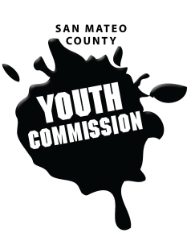
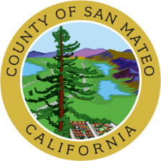
San Mateo County Youth Commission
225 37th Avenue – Room 100
San Mateo, CA 94403

1/16/20
6:15-8:15 PM
Community Agreements

- One mic, one voice
- Use and respect personal pronouns
- Disagree with the idea, not the person
- Food diversity
- Be open to other perspectives
- Be discreet with personal information shared at meetings but know that anything shared is public record
- Keep homework and phones away
- HAVE FUN!

Workgroup

- Call to Order

- Roll Call

- Public Comment
Members of the public may address the commission on youth related issues and concerns that are not currently on the agenda. Please complete a Request Form found in the front entry, hand it to one of the Youth Commission Chairs, and limit your remarks to two minutes. The public is welcome to speak on Agenda Items throughout the meeting.

- Approve Agenda (Action)

- Approve Minutes (Action)

- Breakfast Up! School Breakfast Participation Event – Vote on Co-Sponsorship (Action)
Heather Hopkins, Belle Haven Action

- Children’s Collaborative for Community Success – Vote on Drafting a Letter of Support (Action)
Maeve Johnston, Public Health, Policy, and Planning

- Mental Health Letter to BOS – Vote on Letter (Action)
Health and Wellness Committee
- Individuals with Disabilities Education Act Letter to BOS – Vote on Letter (Action)
Health and Wellness Committee

- Climate Crisis Letter, SMCOE Collaboration – Vote on Letter (Action)
Environmental Justice Committee

- Committee Worktime

- Committee Chair and Board and Commission Liaison Updates

- January 30th Meeting: Change of Place/Time
Census Training: 264 Harbor Blvd, Bldg A, (Jupiter Room) Belmont
6:00pm-8:00pm (Dinner will be served starting at 5:30pm)

- Announcements

- Adjournment

Next Executive Board Meeting: February 6, 2020
Next Workgroup Meeting: February 13, 2020
Next Public Meeting: January 30, 2020 – 264 Harbor Blvd,
Bldg A, (Jupiter Room) Belmont, 6:00pm-8:00pm

Public records that relate to any item on the open session agenda for a regular or special meeting of the Youth Commission are available for public inspection. Those records that are distributed less than 72 hours prior to the meeting are available for public inspection at the same time they are distributed to all members, or a majority of the members of the Commission. Those public records are available to be sent electronically by emailing lfreeland@smcgov.org or calling (650) 363-4396.

IN COMPLIANCE WITH THE CALIFORNIA GOVERNMENT CODE AND THE AMERICANS WITH DISABILITIES ACT: The meetings of the Youth Commission are accessible to individuals with disabilities. Contact Lindsey Freeland at (650) (650) 363-4396 or at lfreeland@smcgov.org as soon as possible prior to the meeting, if (1) you need special assistance or a disability-related modification or accommodation, including auxiliary aids or services, in order to participate in this meeting; or (2) you have a disability and wish to receive the meeting notice, agenda packet or other writings that may be distributed at the meeting in an alternative format. Notification in advance of the meeting will enable the Youth Commission to make reasonable arrangements to ensure full accessibility to this meeting and the materials related to it.

